

AGILE SYSTEMS

28th February 2020

ADIRA-STRONG AND NOBLE

A WOMEN SECURITY APP

**Submitted To:**

**Dr. Durgansh Sharma**

**Associate Professor**

**University of Petroleum and Energy Studies**

**BY: MIND BENDERS**

|  |  |  |
| --- | --- | --- |
|  |  |  |
| **GROUP MEMBERS** | **ROLL NO.** | **SAP ID** |
| Aditi Sinha | R174218003 | 500066712 |
| Khushboo Saini | R174218021 | 500066934 |
| Priyanshi Gupta | R174218038 | 500070513 |

Table of Contents

AGILE MANIFESTO 5

PRINCIPLES 6

ABSTRACT 7

INTRODUCTION 8

PROBLEM STATEMENT 10

REVIEW 11

Description 11

Pros 11

Cons 11

SYSTEM MODULES 12

Profile Module 12

Police Station 12

Emergency Contacts 12

Emergency Button 12

ENTITY RELATIONSHIP DIAGRAM 13

DATA FLOW DIAGRAM 14

DFD LEVEL - o 14

DFD LEVEL – 1 14

DFD LEVEL - 2 14

GENERAL METHODOLOGY OF APPLICATION 17

DATA ANALYSIS 18

PROCESS FLOW 21

PROGRAM EVALUATION AND REVIEW TECHNIQUE (PERT) 22

SOFTWARE ENGINEERING METHODOLOGY 23

SCRUM DEVELOPMENT 23

Scrum Roles 23

Product Backlog 23

Agile Sprint Backlog and Planning 23

Daily Scrum Meeting 24

Agile Sprint Review 24

Increment 24

Learn. Repeat. Improve. 24

DEVELOPMENT 25

PROJECT PLANNING AND CONTROL 26

Planning is necessary 26

Risk analysis 26

Tracking of project plan 27

Meet quality standards and produce quality deliverables 27

Description of flexibility to accommodate changes 27

Identification of project requirements 28

Identification of cost estimates 28

Identification of riskS 28

Identification of critical success factors 28

Preparation of project charter 28

Preparation of project plan 29

Commencement of the project 29

Control 30

Measure and analyze results of reviews and testing 30

Monitor and document progress, test coverage and exit criteria 30

Provide information on testing 30

Initiate corrective actions 31

Make decisions 31

# 

# 

# AGILE MANIFESTO

We are uncovering better ways of developing software by doing it and helping others do it. Through this work we have come to value:

* **Individuals & interactions** over processes and tools.
* **Working software** over comprehensive documentation.
* **Customer collaboration** over contract negotiation.
* **Responding to change** over following a plan.

That is while there is value in the items on the right, we value the items on the left more.

Kent Beck James Grenning Robert C. Martin

Mike Beedle Jim Highsmith Steve Mellor

Arie van Bennekum Andrew Hunt Ken Schwaber

Alistair Cockburn Ron Jeffries Jeff Sutherland

Ward Cunninghum Jon Kern Dave Thomas

Martin Fowler Brain Marick

# PRINCIPLES

*We follow these principles:*

* Our highest priority is to satisfy the customer through early & continuous delivery of valuable software.
* Welcome changing requirements, even late in development. Agile processes harness change for the customer’s competitive advantage.
* Deliver working software frequently, from a couple of weeks to couple of months, with preference to the shorter timescale.
* Business people and developers must work together daily throughout the project.
* Build projects around motivated individuals. Give them the environment and support they need and trust them to get the job done.
* The most efficient & effective method of conveying information to & within a development team is face-to-face conversation.
* Working software is the primary measure of progress.
* Agile processes promote sustainable development. The sponsors, developers & users should be able to maintain a constant pace indefinitely.
* Continuous attention to technical excellence & good design enhances agility.
* Simplicity-the art of maximizing the amount of work not done is essential.
* The best architectures, requirements, and designs emerge from self-organizing teams.
* At regular intervals, the team reflects on how to become more effective then tunes and adjusts its behavior accordingly.

# ABSTRACT

Our venture “**ADIRA-STRONG & NOBLE**” is a security based application which will be utilized for self- assurance. We thought of the idea ‘ADIRA’ (A women security app) which is a Hebrew word that implies Strong noble and powerful.. It is based on android application. This application can be utilized on smart phones, tablets, television. In short, what the client need to do is to link herself from the app & when the client faces any risk, she simply needs to dial that emergency contact number with the goal that the client’s relatives can follow them. The app will likewise give the maps to the closest police stations and will also map the places where the user can learn self-defence and can shield herself from the foe & permit to have a correspondence through online message interface, audio recording & a video recording interface.

# INTRODUCTION

* The closet to “**INDIVIDUALS AND INTERACTIONS over processes &** **tools”** is an initiative taking process as our project indulges with the user and interact with the relative as the user finds any threats around her. It takes an initiative for valuing people more highly because they respond to the needs of the user. Communication & interactions between the individuals justifies a proper requirement when a need arises.
* People are adapted of using mobile phones everywhere that traits a **“WORKING SOFTWARE over comprehensive documentation”** that is diversified for a social cause or

mis-happening with anyone around. The efficient way to minimize the chances of becoming a victim of violent crime is to identify and resource yourself from the security app in order to get out of dangerous situations.

* **“CUSTOMER COLLABORATION over contract negotiation”** clarifies the user as the client collaborates throughout in the making of the development process. Waterfall model stimulates the requirement for the product, prior to negotiation. Our app accommodates with scrum development. It is trust worthy and motivates the people around for a consistent support pace.
* **“RESPONDING TO CHANGE over a following plan”** with the intention of developing plans that illustrates the approach of an individual’s capability that determines change as an expense. Our app is a positive change that will help the user in every manner by an alignment through people’s signatories. The positive changes provide an additional value that uncovers its impact on negotiation.

These 4 manifesto’s are meant to guide and inspire us to build secure software in an efficient way. The agile approach to software development is defined by the commitment of creating software incrementally. The approach offers new versions or releases of the software that follow brief periods of work. It may involve the collaborative work of multiple self-organizing teams composed of members who have different functional expertise but are working for the achievement of a common goal. The manifesto also wants to prioritize the creation of working software, not the generation of documentation, collaboration with the client instead of spending more time on contact negotiation.

# PROBLEM STATEMENT

Nowadays, physical harassment is one of the most common & frequently happening against females in India. The metro cities have more number of physical harassment cases compared to other countries. Developing country like India have less number of incidences where very good security facility are provided by the government but still there are many females who are facing physical harassment. It is also revealed that in 98% cases, the culprit is someone close to the victim like relative or neighbor. It is not possible to keep watch on each house every time.

**ADIRA** is a safety device available for female’s self-protection in situation like rape & assaults and adds a new perspective of using android smart phones with GPS for females safety.

* The app provides a help line number to the females.
* It also provides the live location to the given number.

# REVIEW

## Description

The app can be activated by a single click when the user feels she is in danger. The application maps the user’s location to the registered contacts for every few seconds in the form of message. The key features of this application are along with the user’s location, one of the registered contacts gets a call. Also, the registered contacts and GPS location are saved from time to time in a database.

## Pros

This app continuously fetch the location for an interval of every 30 seconds and send it to the registered contact. So, we can easily track the user and it will also send the location in the form of URL.

## Cons

This app will work at the time of danger so it is not that feasible for a user to instantly if she is in trouble. The whole process of the system is done only when the device is connected to proper mobile network, data connection of the device is on and location service in the device is switched on (GPS).

# SYSTEM MODULES

Our project contains the following four modules:

## Profile Module

Profile is an important component to users, which helps users to add her personal details.

Name, Address, Email ID, Mobile Number.

## Police Station

The user will get information about the nearer police station.

## Emergency Contacts

Required details of one who is in danger will be contacted to the right person or family members or friends or help lines.

## Emergency Button

When we sense any danger, we can escape by using emergency button.

# ENTITY RELATIONSHIP DIAGRAM

# 

# DATA FLOW DIAGRAM

## DFD LEVEL - o

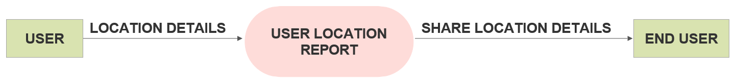

## DFD LEVEL – 1

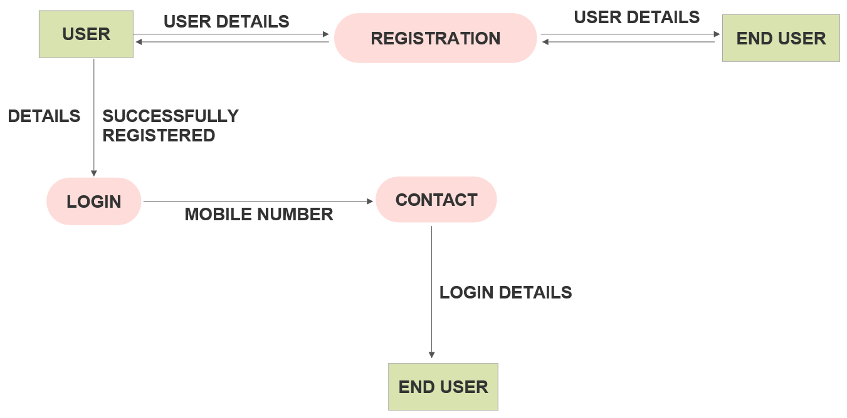

## DFD LEVEL - 2

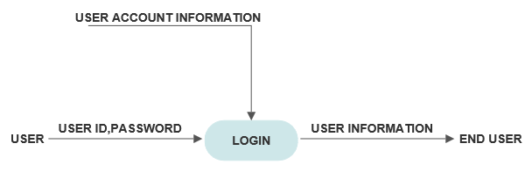

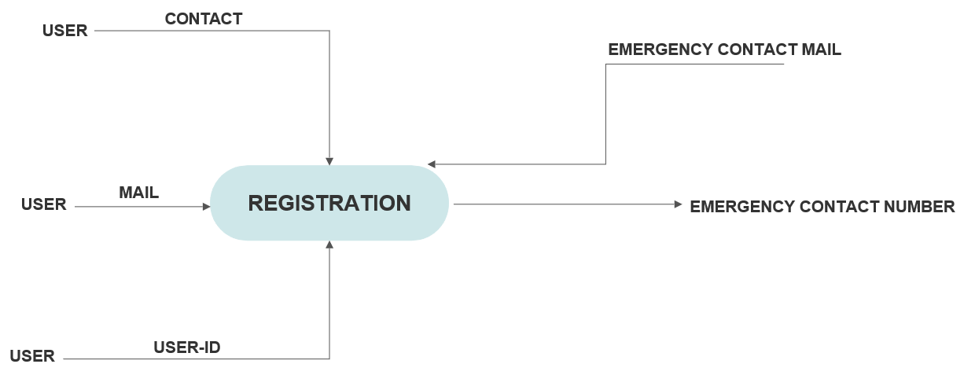

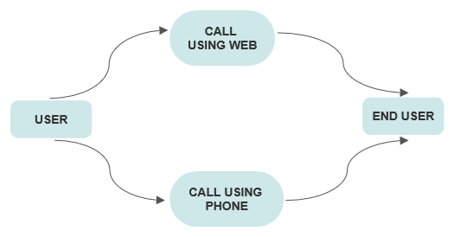

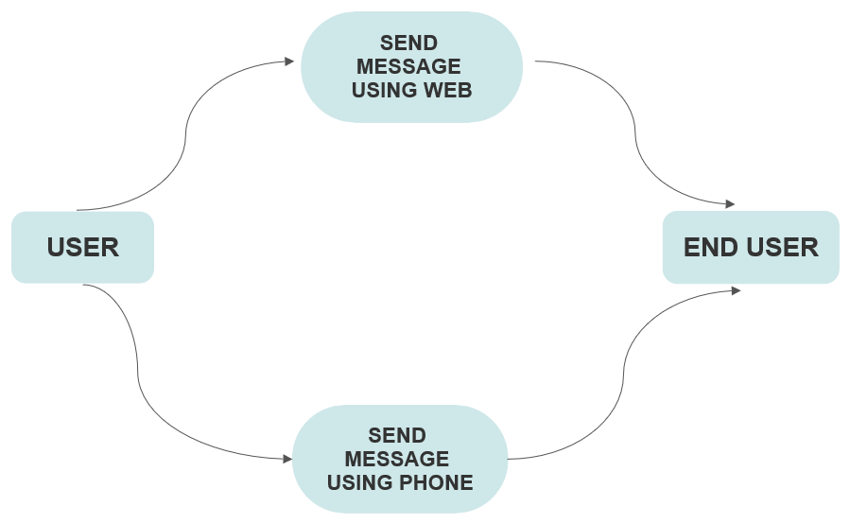

# GENERAL METHODOLOGY OF APPLICATION

Personal safety has become an important issue for everyone, but specially for females. The current females safety device can be activated by just pressing the panic button. This device gets activated and sends instant location with a distress message to the pre set numbers.

In addition this device make :

* Call to the pre set numbers.
* Surrounding captured images.
* GPS location information about the victim along with longitude and latitude.



# 

# DATA ANALYSIS

Survey Questions

1. Do you feel safe going out alone?

Yes-

No-

No answer-

2. Do you feel safe in day or night?

Day-

Night-

Both A and B-

No answer-

3. Females feel safe in Public Transport?

Yes-

No-

No answer-

4. Do you feel comfortable in sharing cabs?

Yes-

No-

No answer-

5. Do you carry something(like pepper spray, chilli powder etc) for your safety?

Yes-

No-

No answer-

6. Do you know any technique for your safety?

Yes-

No-

No answer

7. Are you satisfied with government initiatives for women safety?

Yes-

No-

No answer-

8. Women safety Apps are helpful?

Yes-

No-

No answer-

9. What suggestions would you like to give to increase the safety of women?

* Need more actions to be taken
* It is important to evaluate the goals and practical usefulness of a womens self-defense program .
* Just make your son understand that women are not toys.
* Govt. Should take major steps regarding this rather than just ta
* 24hrs police personnel in the trains
* Stay away from those from who u are not comfortable with.
* No idea
* Change the government rules and regulations
* Stick to your commitment to government.hang each rapist with a week even if he is a minor. Public support girls don't be watcher's or recorders
* Police must be strictly
* Everyone should be help each other at any point of time
* Women safety measures and awareness programms should bhi organizaed
* it's not about the government. it's about the education of not only boys but girls too.
* Police should be more attentive and give fast response
* Change of thought process
* Honest administration who works for the society
* Fight for safety
* We need to learn self defense and strong laws should be made against crimes
* Government should be make a strict action and rules for safety section and I m sorry to say our man and woman police staf are not helpful so make a better idea for all side of our society some how to effect the mentality of society.
* Strict Laws, women safety camps and awareness about the cause.
* Self defence should be taught to girls, right from the beginning. It should be a part of school curriculum and it should be responsibility of government as these things are not economically feasible every other girl of our country. Immediate need of systemic reforms in the women Helplines, restructured steps should be taken so that immediate help could reach the women at the Time of need.
* Take a chilly spray .etc with us
* They should make law powerful towards protection of women
* Remove crime
* We should avoid acid attack nd rape
* Dear sir/mam..thanks aap log girls ki saftey ke liye app bna rhe ho .mujhe ghr se RT ko bhr Jane m dar lgta h..ghr se bhr niklti hu toh sochti hu ki ghr safe pahuchungi bhi ya nhi..society Hume hamare kapde se judge krti h..agr humne shorts phne h toh hum Carteracterless h le suit toh hum sanskrit.. yeh soch samaj ko ander se khokla krke baith gyi h...m bhi nhi janti rape hone kb bnd hoga..bs itna samjhti hu agr hamare ghr m hum apne bhaiyo ko jis din yeh samjha diya ki jaise m teri bhn hu dusri ldki bhi kisi ki bhn ..maa or beti h agr mera bhai meri protection kr sakta h toh us ldki ko woh apni bhn kyu nhi samjh sakta...jis din ghr m beto ko beti ki respect krna sikha diya us din syd hum safe ho jayenge..

Dont trust anyone and help yourself by yourself

I think sabko apni soch achhi rakhni chiye takki koi dikkat hi na ho

Teach self defense

# PROCESS FLOW

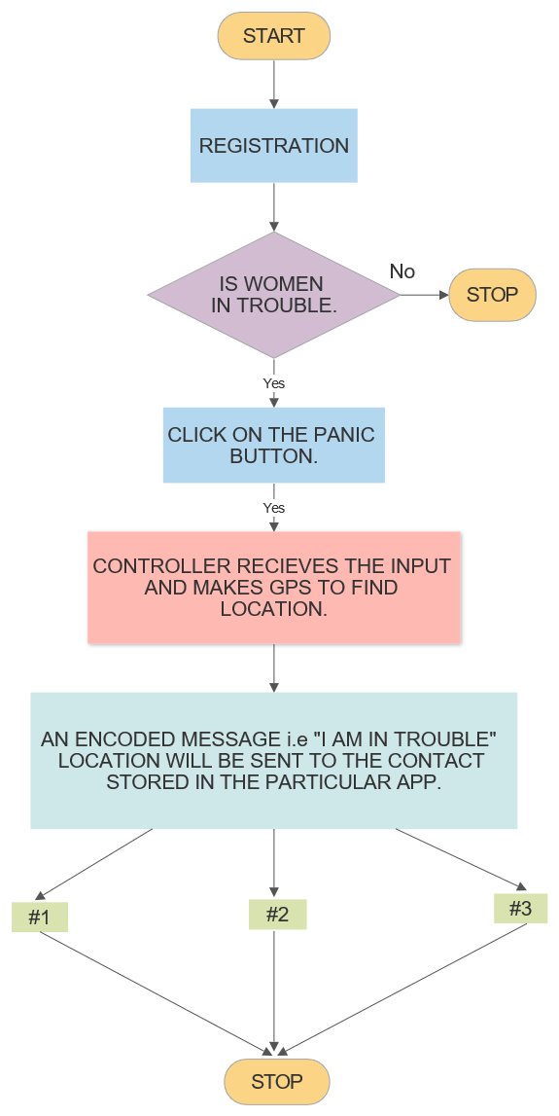

# PROGRAM EVALUATION AND REVIEW TECHNIQUE (PERT)

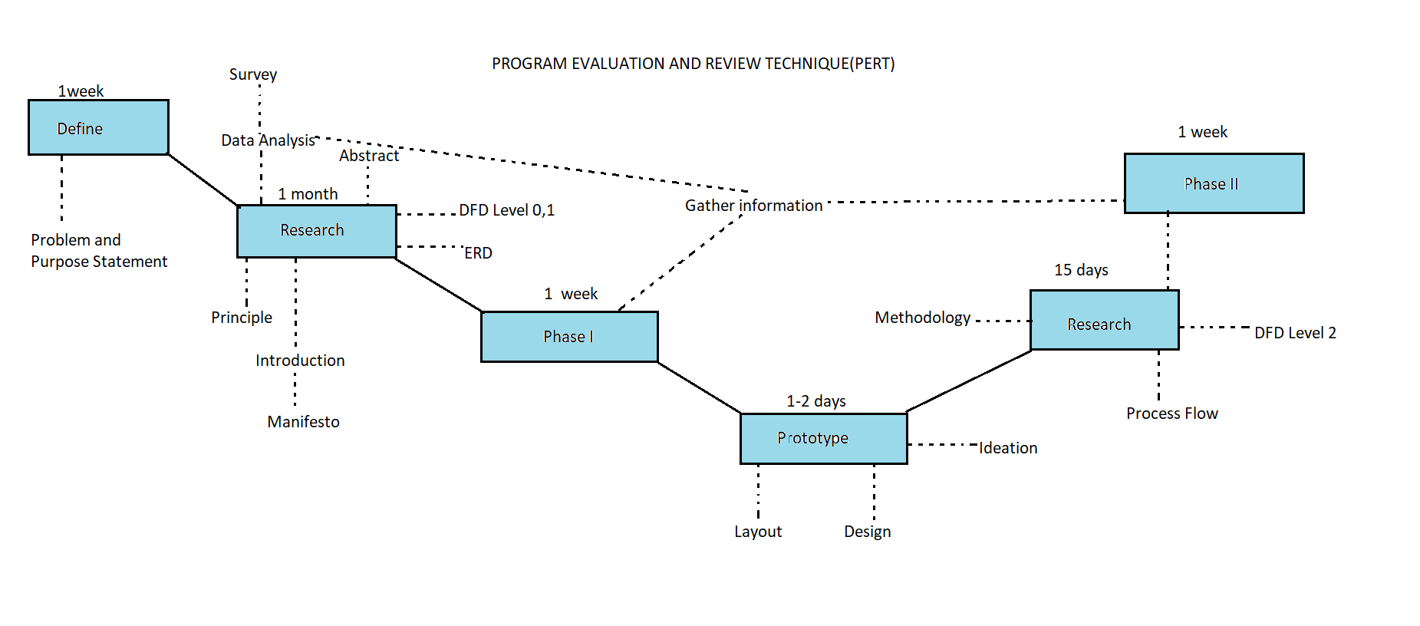

# SOFTWARE ENGINEERING METHODOLOGY

## SCRUM DEVELOPMENT

Holistically, the role of Agile in mobile apps is well-renowned and Scrum is the most commonly used sub domain of the agile methodology, which has quickly expanded to handling big, complicated projects that might have otherwise taken a lot of time to finish.

Used mostly by[**mobile application development services companies**](https://appinventiv.com/) or software based agencies, the scrum team break down their allotted work aka product backlogs in actions, which they could cover within the two-week cycles, also known as “sprints” By the completion of every sprint, the team is expected to produce a working mobile app, which they continue to work upon and improve.

Every sprint comes with a timeline that extends from 2 months to maximum 4 months. And each of them has these following components to make the [**agile mobile app development**](https://appinventiv.com/blog/reasons-why-we-trust-agile-for-our-mobile-app-development-process/)more efficient.

## Scrum Roles

**Project Manager** – Is responsible for overlooking what the team is working on and is also responsible for ensuring that the backlog is up to date.

**Scrum Master** – Is assigned to ensure that the agile scrum is followed rightly by the team. They are also responsible for overlooking how the team is performing and then resolving any issue that is coming up.

**Scrum Team** – They are the ones who are actually doing the tasks. They own the development and testing part of the whole project.

## Product Backlog

Handled by the project manager, product backlog is a list of tasks that the team needs to perform. The modifications and priorities are set as and when needed.

The idea is to have a list of backlogs ready before the sprint starts.

## Agile Sprint Backlog and Planning

In this scrum methodology step, the ADIRA team decides on the backlogs they will be targeting on in the current sprint. Sprint backlog is the list of things the team plans on achieving in the delivery. Usually, sprint backlogs are divided into workable actions and once the team agrees upon the backlog items, the sprint begins.

## Daily Scrum Meeting

Once the above steps of agile methodology are done and the team starts working on the product backlogs, a practice called daily scrum is initiated. A stand up daily meeting is held every day for 15 minutes. In the daily scrum everyone in the team tells about the last day’s work and the day’s plan. The daily scrum lets everyone in the team know of the whole project’s progress.

## Agile Sprint Review

After every agile sprint, the team demonstrates what was developed to the stakeholders and look into the steps where they got stuck and which went well. The findings of one sprint become the action statement of the next.

## Increment

The end result of a scrum is called Increment. The aim of everyone involved in a scrum is to deliver an increment that is complete on its own. It should adhere to all the quality standards set by the product owner and team.

## Learn. Repeat. Improve.

This entire cycle is repeated in the next sprint.

Sprint Planning chooses the next set of items in the Product Backlog and the sprint cycle starts again. As the team executes the Sprint, the Agile Product Owner simultaneously ensures that the items which are on top of the product backlog are executed first in the next Sprint.

# DEVELOPMENT

* Make sure that you have tested the app before the unveiling so that there is no compromise with the quality of app. The testing includes external as well as internal in which you have to remove all sorts of bugs and also need to choose the appropriate testing tools.
* Keep a Strict Vigil on the App Performance- If you want to keep the app quality on the top then the one thing that will help you stand out in the crowd is venerable performance of your app. Do not make your app functionality to only collect data and records. Though it is important but performance is must.
* In the current scenario, the security is supreme and considering the fact that cyber threat is increasing. The app security should be on the top of priority list. Do not ignore if you want to maintain the quality and standard of app. In addition, when the user needs to login her details to enter, then you must employ the verification process. You have to take account what the risks factors are and then plan a strategy accordingly.
* Have a clear vision in mind- You need to have a clear vision of what you are going to develop. App Documentation is very essential for keeping the quality of the application up to the mark. Do try to be simple in design.
* It is a good idea to evaluate the efficiency of each of the team members before you can assign them with a task.
* Taking the Reviews and Rating Seriously: If you don’t want your app quality to suffer and wish them to remain always connected with the end users, then you have to consider the reviews and ratings very seriously.

Since the users have become very smart in their choice of installing the mobile apps, you need to vary of the quality and ensure at all cost that it does not decline. It is the quality of app that will get you more traffic.

# PROJECT PLANNING AND CONTROL

Project planning is an organized and integrated management process, which focuses on activities required for successful completion of the project. It prevents obstacles that arise in the project such as changes in projects or organization's objectives, non-availability of resources, and so on. Project planning also helps in better utilization of resources and optimal usage of the allotted time for a project. The other objectives of project planning are listed below.

* It defines the roles and responsibilities of the project management team members.
* It ensures that the project management team works according to the business objectives.
* It checks feasibility of the schedule and user requirements.
* It determines project constraints.

Project planning should be effective so that the project begins with well-defined tasks. Effective project planning helps to minimize the additional costs incurred on the project while it is in progress. For effective project planning, some principles are followed. These principles are listed below.

Planning is necessary

Planning should be done before a project begins. For effective planning, objectives and schedules should be clear and understandable.

Risk analysis

 Before starting the project, senior management and the project management team should consider the risks that may affect the project. For example, the user may desire changes in requirements while the project is in progress. In such a case, the estimation of time and cost should be done according to those requirements (new requirements).

Tracking of project plan

 Once the project plan is prepared, it should be tracked and modified accordingly.

Meet quality standards and produce quality deliverables

The project plan should identify processes by which the project management team can ensure quality in software. Based on the process selected for ensuring quality, the time and cost for the project is estimated.

Description of flexibility to accommodate changes

 The result of project planning is recorded in the form of a project plan, which should allow new changes to be accommodated when the project is in progress.

Project planning process comprises several activities, which are essential for carrying out a project systematically. These activities refer to the series of tasks performed over a period of time for developing the software. These activities include estimation of time, effort, and resources required and risks associated with the project.

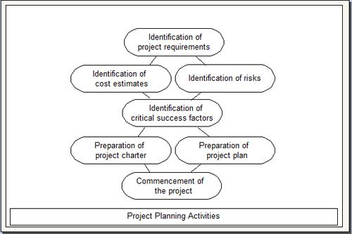

Project planning process consists of the following activities.

Identification of project requirements

 Before starting a project, it is essential to identify the project requirements as identification of project requirements helps in performing the activities in a systematic manner. These requirements comprise information such as project scope, data and functionality required in the software, and roles of the project management team members.

Identification of cost estimates

 Along with the estimation of effort and time, it is necessary to estimate the cost that is to be incurred on a project. The cost estimation includes the cost of hardware, network connections, and the cost required for the maintenance of hardware components. In addition, cost is estimated for the individuals involved in the project.

Identification of riskS

 Risks are unexpected events that have an adverse effect on the project. Software project involves several risks (like technical risks and business risks) that affect the project schedule and increase the cost of the project. Identifying risks before a project begins helps in understanding their probable extent of impact on the project.

Identification of critical success factors

 For making a project successful, critical success factors are followed. These factors refer to the conditions that ensure greater chances of success of a project. Generally, these factors include support from management, appropriate budget, appropriate schedule, and skilled software engineers.

Preparation of project charter

 A project charter provides a brief description of the project scope, quality, time, cost, and resource constraints as described during project planning. It is prepared by the management for approval from the sponsor of the project.

Preparation of project plan

 A project plan provides information about the resources that are available for the project, individuals involved in the project, and the schedule according to which the project is to be carried out.

Commencement of the project

 Once the project planning is complete and resources are assigned to team members, the software project commences.

Control

Control is an ongoing activity throughout the Software development life cycle. Management of any activity completes after successful control over planned activities. We need to control and measure progress against the plan to compare actual progress against the planned progress, and we should report to the project manager and customer on the current status of testing, including any changes or deviations from the plan. We'll need to take actions where necessary to meet the objectives of the project. Such actions may entail changing our original plan, which often happens. Test control has the following major tasks:

1. Measure and analyze results of reviews and testing.

2. Monitor and document progress, test coverage and exit criteria.

3. Provide information on testing.

4. Initiate corrective actions.

5. Make decisions.

Measure and analyze results of reviews and testing

We need to know how many reviews and tests we have done. We need to track how many tests have passed and how many failed, along with the number, severity & priority of the defects reported.

Monitor and document progress, test coverage and exit criteria

It is important that we inform the project team how much testing has been done, what the results are, and what conclusions and risk assessment we have made. We must make the test outcome visible and useful to the whole team.

Provide information on testing

We should expect to make regular and exceptional reports to the project manager and other key stakeholders to help them make informed decisions about project status. We should also use the information we have to analyze the testing itself.

Initiate corrective actions

For example, tighten exit criteria for defects fixed, ask for more effort to be put into debugging or prioritize defects for fixing test blockers.

Make decisions

Based on the measures and information gathered during testing and any changes to business and project risks or our increased understanding of technical and product risks, we'll make decisions or enable others to make decisions, to continue or stop testing, to release the software or to retain it for further work.